**DAILY ONLINE ACTIVITIES SUMMARY**

|  |  |  |  |  |  |  |  |  |
| --- | --- | --- | --- | --- | --- | --- | --- | --- |
| **Date:** | **20/06/2020** | | | | | **Name:** | **Nivedita** | |
| **Sem & Sec** | **4th sem /A** | | | | | **USN:** | **4al18cs053** | |
| **Online Test Summary** | | | | | | | | |
| **Subject** | | **DC** | | | | | | |
| **Max. Marks** | | **30** | | **Score** | | | **27** | |
| **Certification Course Summary** | | | | | | | | |
| **Course** | **Entrepreneurship** | | | | | | | |
| **Certificate Provider** | | | **Cisco networking** | | **Duration** | | | **15 hours** |
| **Coding Challenges** | | | | | | | | |
| **Problem Statement:** **Write a Java program to count number of bits to be flipped to convert A to B** | | | | | | | | |
| **Status: done** | | | | | | | | |
| **Uploaded the report in Github** | | | | | **yes** | | | |
| **If yes Repository name** | | | | | [**https://github.com/nivi-nivedita/lockdown-coding-program/blob/master/java%20program%20(bit%20to%20flipped%20to%20convert).txt**](https://github.com/nivi-nivedita/lockdown-coding-program/blob/master/java%20program%20(bit%20to%20flipped%20to%20convert).txt) | | | |
| **Uploaded the report in slack** | | | | | **yes** | | | |

Online test Details : today I took DC exam at 2pm for 30 questions.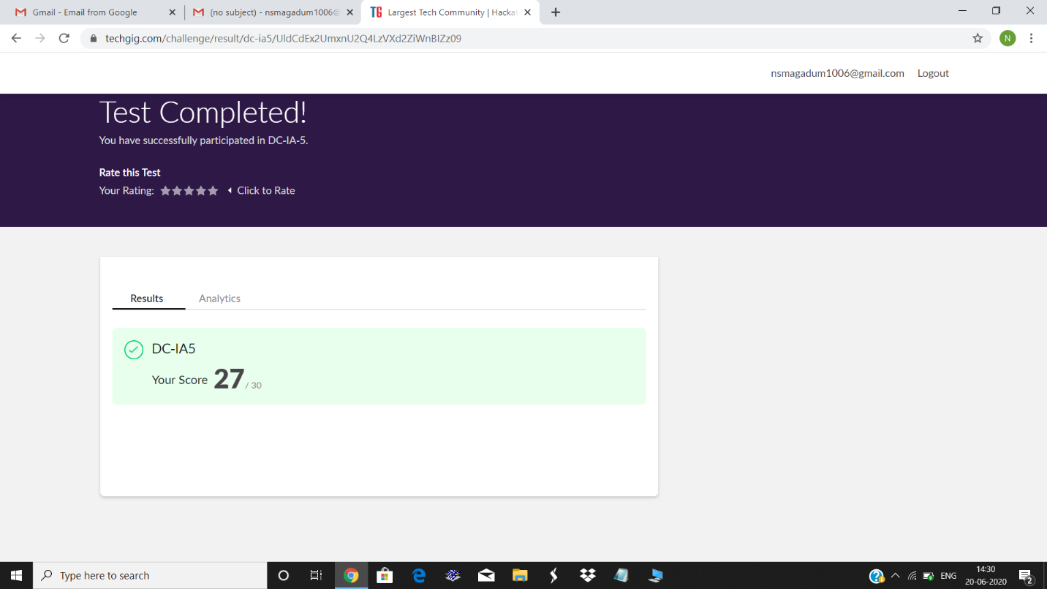

Certification Course Details: I continued course and completed 3 modules.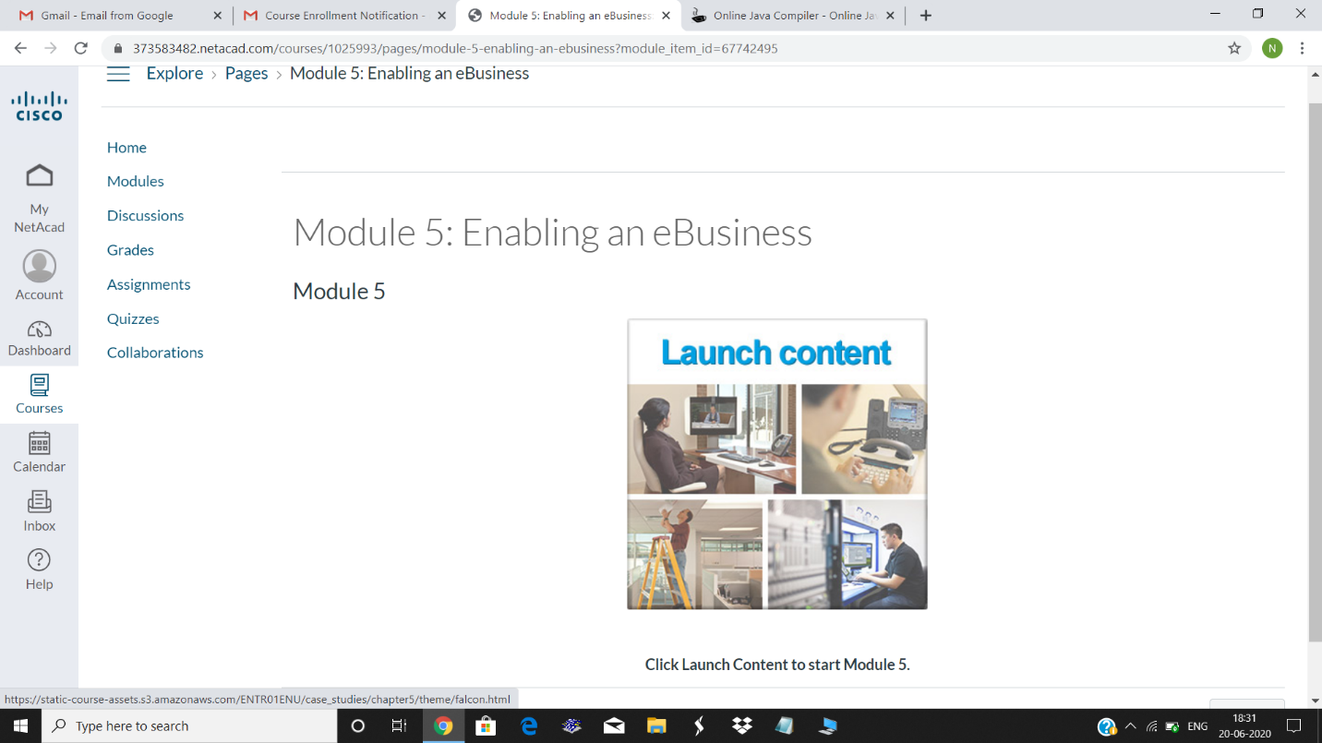

Coding Challenges Details: Write a Java program to count number of bits to be flipped to convert A to B.

Executed and uploaded

